T922/822 T920/820 Set UP

tools
- 5mm Allen Key – for mounting bolts
- 4mm Allen Key – for brake pad adjusting bolts
- 3mm Allen Key – for clamping bolt adjustment (certain models)
- 2.5mm Allen Key – for Noodle and Clamping Bolt adjustment
- 2mm Allen Key – for brake adjustment screws

T – 822 / T – 922
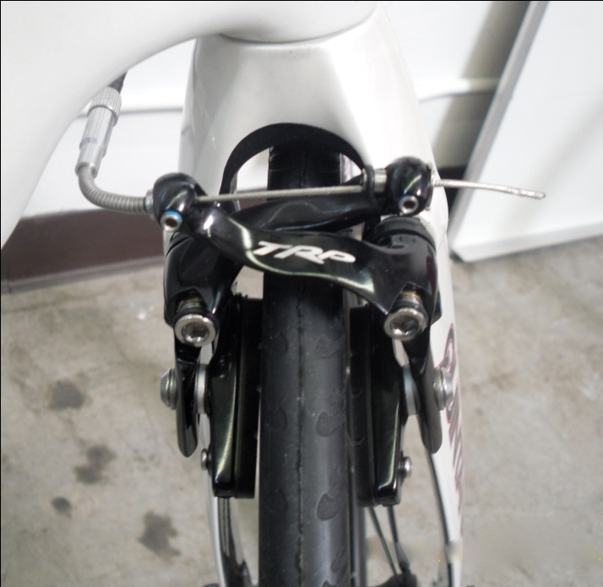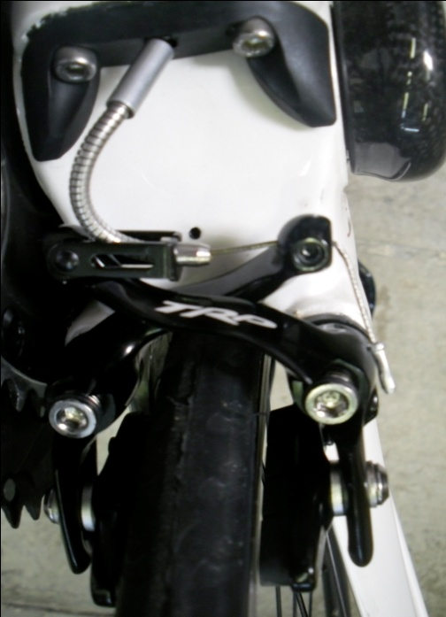

Instructions – Front (T-822/922) Brake Set Up
- Mount Left side caliper arm first, always.
- Mount Right side caliper arm.
- Choose Which Side Pulls – T-822/922 brakes give you the choice of mounting the pull on either the right (‘R) or left side (L) as best suits your needs. Decide how you want to mount the noodle and then you’re ready
  - Be sure to mount the cable clamping plates on the opposite side from the noodle.
  - Cable clamping plates (2) must be perpendicular to the ground to the 2.5mm mounting screws, allowing the screw to seat properly, with the O-ring secured inside, towards the center of the brake/wheel.
  - Once you have secured the side opposite the noodle, go back and tighten the 2.5mm mounting screws on the same side as the noodle. This helps set the alignment of your noodle in a fixed position.
- Route brake cable through the Noodle/right side caliper, and then through the cable clamping plates and left side caliper. Now your brakes are ready to be dialed in!
- Balancing the Brakes – the brakes are most effective when they are properly centered. To balance the springs:
  - R and L brake arm each have a 2.5mm adjustment screw to center the brakes. Simply twist the adjustment screw until the brake is centered.
  - Adjustment Screw Troubleshooting: Occasionally, when mounting the brake calipers on the posts, the small spring tension adjuster plate that aligns the brakes will slip and cover the hole that the adjustment screw sits in. If this happens it is impossible to align the calipers or seat the screw. Fortunately it is an easy fix. Using a small screwdriver or pen simply slide the tension spring adjuster plate counter-clockwise until the adjusting screw bolt hole is visible, then proceed with installing the adjuster screw. See photos below for details:

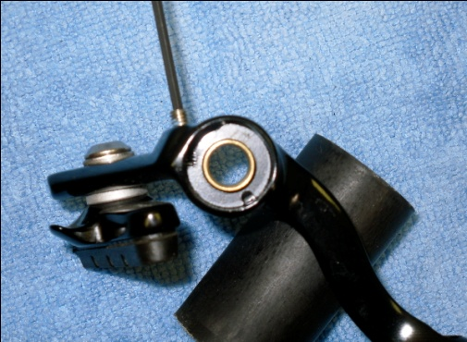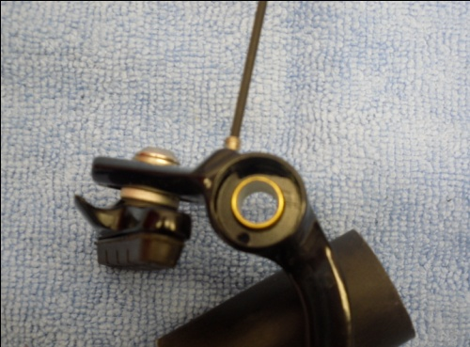
Tension Adjuster Plate – Correct Position Tension Adjuster Plate – Blocking Adjuster Screw

Instructions – Rear (T-822.1) Brake Set Up
- T-822.1 is a Center Pull Brake, mounted under the bottom bracket.
- Mount Left side caliper arm first, always.
- Mount Right side caliper arm.
- Choose Which Side Pulls – T-822 Series brakes give you the choice of mounting the pull on either the right (‘R) or left side (L) as best suits your needs. Decide how you want to mount the noodle and then you’re ready
  - Be sure to mount the cable clamping plates on the opposite side from the noodle.
  - Cable clamping plates (2) must be perpendicular to the 2.5mm mounting screws, allowing the screw to seat properly, with the O-ring secured inside, towards the center of the brake/wheel.
  - Once you have secured the side opposite the noodle, go back and tighten the 2.5mm mounting screws on the same side as the noodle. This helps set the alignment of your noodle in a fixed position.
- Route brake cable through the Noodle/right side caliper, and then through the cable clamping plates and left side caliper. Now your brakes are ready to be dialed in!
- Balancing the Brakes – the brakes are most effective when they are properly centered. To balance the springs:
  - R and L brake arm each have a 2.5mm adjustment screw to center the brakes. Simply twist the adjustment screw until the brake is centered.
Adjustment Screw Troubleshooting: Occasionally, when mounting the brake calipers on the posts, the small spring tension adjuster plate that aligns the brakes will slip and cover the hole that the adjustment screw sits in. If this happens it is impossible to align the calipers or seat the screw. Fortunately it is an easy fix. Using a small screwdriver or pen simply slide the tension spring adjuster plate counter-clockwise until the adjusting screw bolt hole is visible, then proceed with installing the adjuster screw. See photos below for details:

Tension Adjuster Plate – Correct Position Tension Adjuster Plate – Blocking Adjuster Screw

T- 822 / 922 Series Variations:
- Wide Rims: Many high performance manufacturers like Zipp and HED are moving to a wider 25mm cross section rims. These rims require a wider spacing for the brakes to align properly and function correctly. If you are using this new generation of rims with your T-822/922 brakes simply remove the larger in-board washer from the pad holder. The pad holder will then seat against the brake caliper and allow additional spacing for the wider rim.

